**Screen capture of Unit Testing:**

**RestaurantSearch Service:**

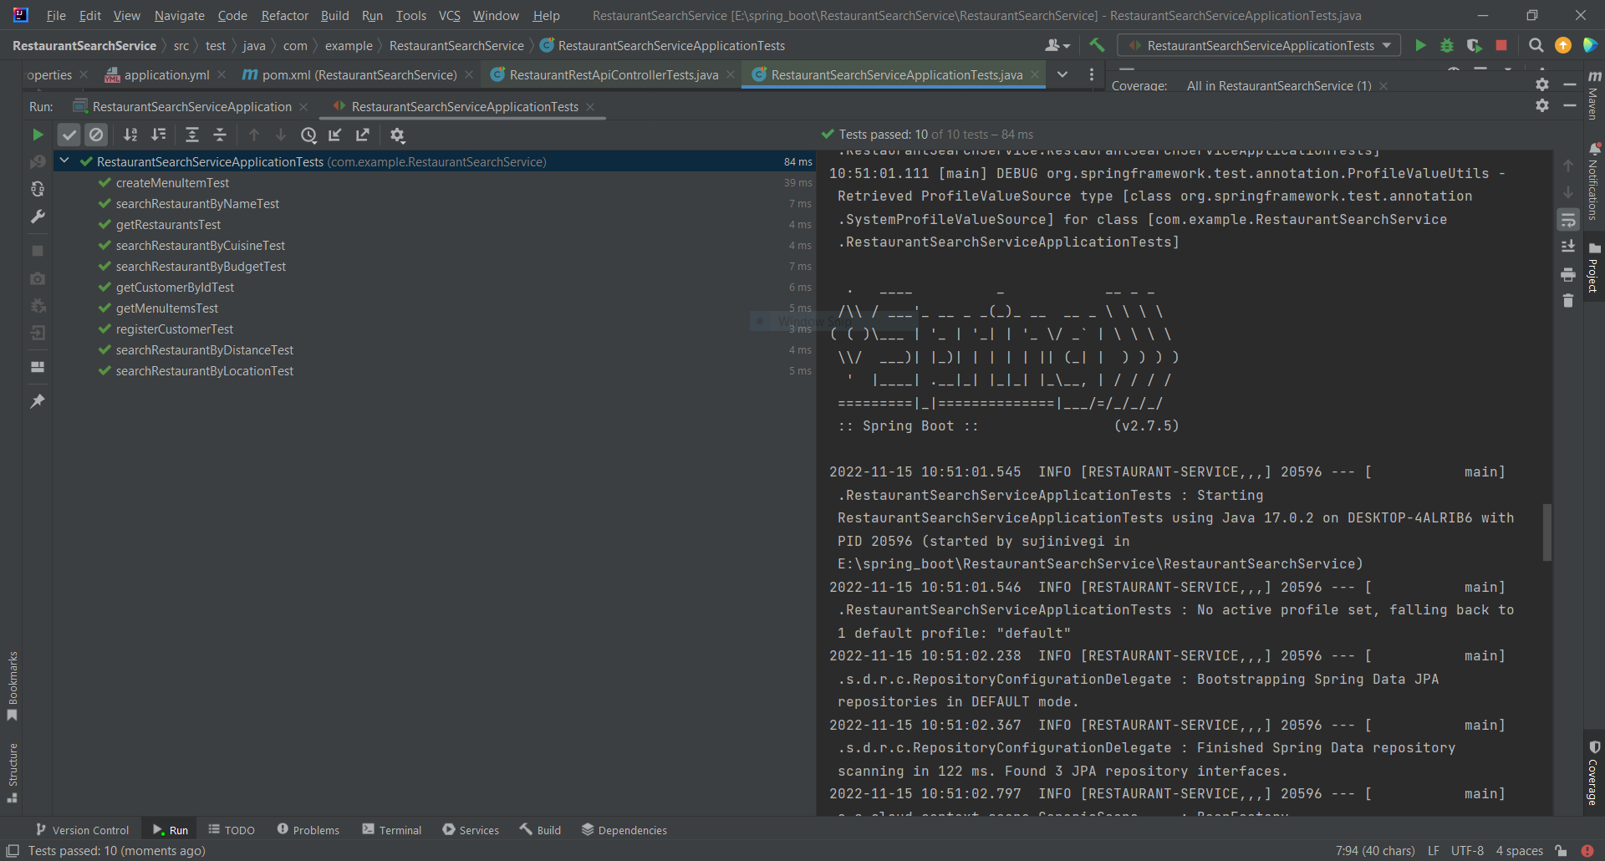

OrderManagement Service:

